Assignment 8.2

Problem Statement:
Write a hive UDF that implements functionality of string concat_ws(string SEP, array). This UDF will accept two arguments, one string and one array of string. It will return a single string where all the elements of the array are separated by the SEP.

Creating UDF class

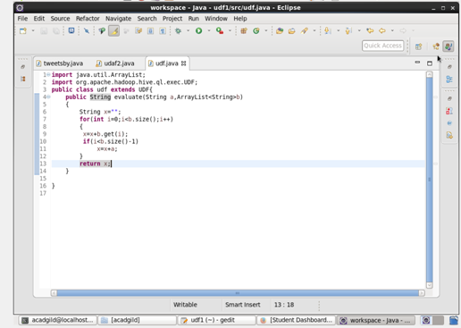

Creating table and loading data in it.
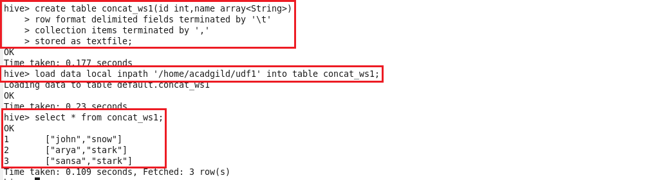

Creating temporary function and using UDF.
